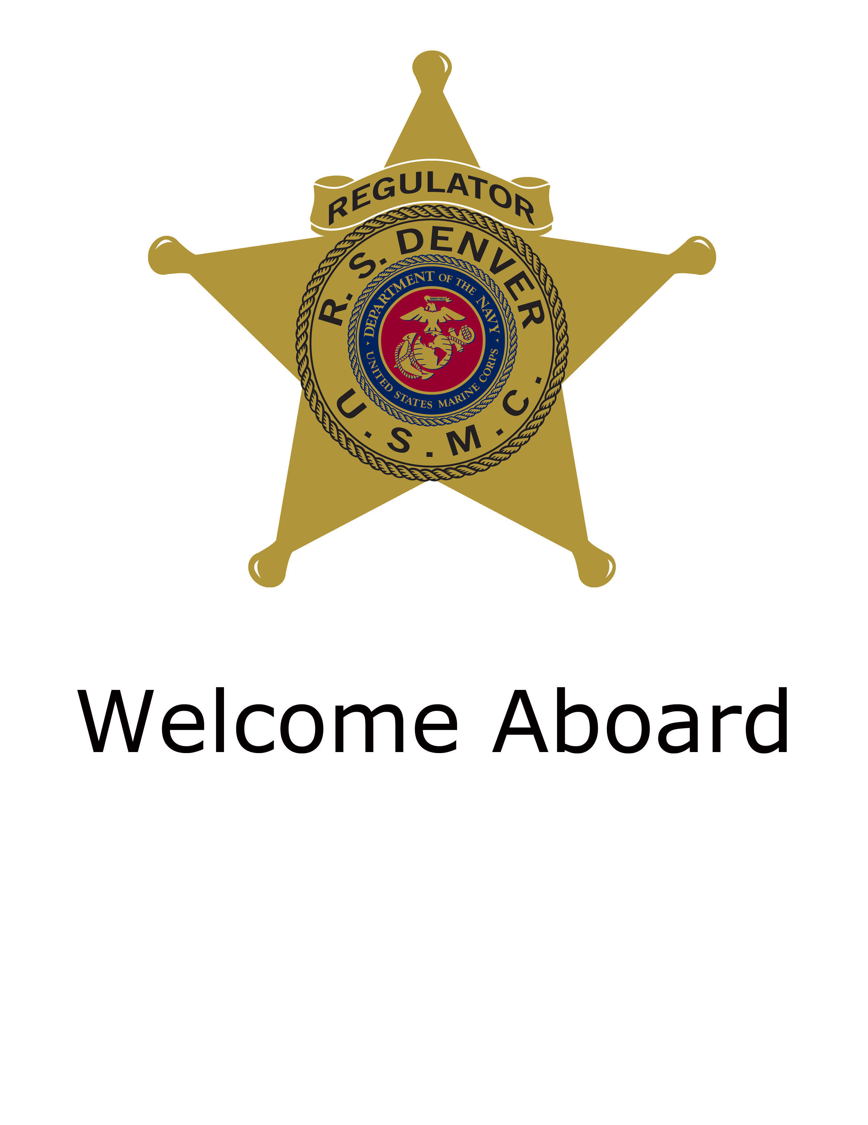

TABLE OF CONTENTS

Commanding Officer’s Guidance Page 3

Sergeant Major’s Guidance Page 4

SNCOIC’s Guidance Page 5

Administrative Guidance Page 6

Medical/Dental Page 10

Important numbers Page 11

RS Denver RSS/PCS Phone Numbers Page 12

Recruiting Admin Info Sheet Page 16
COMMANDING OFFICER’S
GUIDANCE

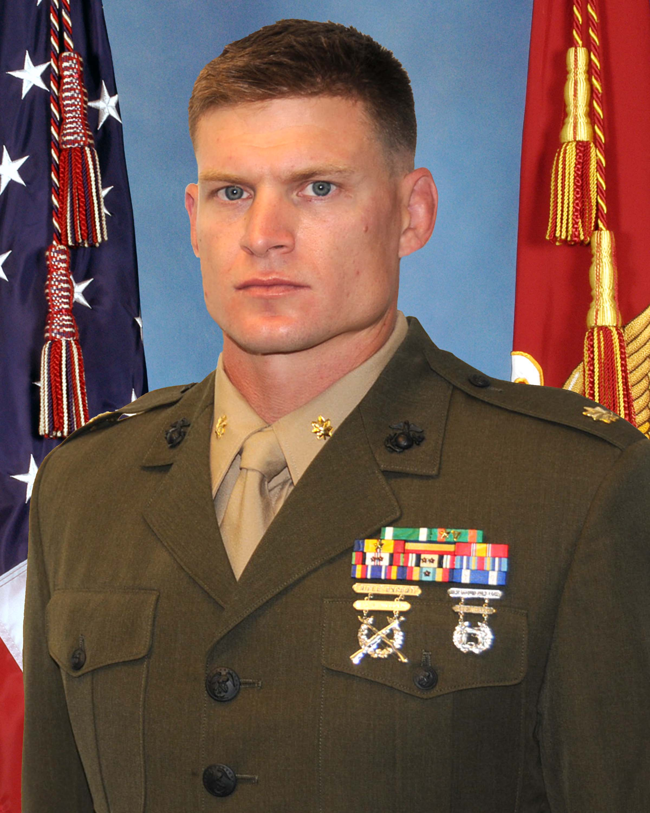
I want to be the first to welcome you to Recruiting
Station Denver, Colorado! This packet will contain information on housing availability, nearby military bases, and tourist attractions in our area and is designed to assist you with a smooth transition to the Rocky Mountain Region. The Sergeant Major will assign you a sponsor in the local area who can provide you with assistance during your move.

I am sure by now you have heard a lot about recruiting duty and Recruiters School has provided you with an outstanding foundation in the execution of your future assignment. Above all else, I have found that the key ingredients to success area positive mental attitude and a sincere effort. I think you will find this duty to be the most rewarding and demanding in the Marine Corps today. I task you with preparing yourself now for a successful future and strongly suggest that you ascertain an abundance of information from your instructors at Recruiters School to learn as much as possible prior to your arrival.

Although you have been assigned to Recruiting Station Denver, the Station itself is responsible for recruiting efforts encompassing the third largest geographical area (217,000 sq mi) in all of the Marine Corps Recruiting Command, operating in a very vast and rural environment. Marines assigned to this command operate in (12) different substations and (14) distinct Permanent Contact Stations (PCS) to include the Denver Metro area, and rural parts of Colorado, Wyoming, South Dakota and Nebraska. I would caution you against purchasing a home or entering into any rental agreements until you have checked into the RS and confirmed the city you will be working in.

You have been chosen for this new and exciting duty based on your unyielding performance in the Marine Corps to date. RS Denver has proved to be a solid and consistent performer for the 8th Marine Corps District and Western Recruiting Region and I am confident you will carry on in this tradition of excellence. I look forward to meeting you upon your arrival at RS Denver and wish you luck in your continued instruction at the Basic Recruiters School. Again, welcome aboard!

Semper Fidelis,

Isaac D. Moore
Major, U.S. Marine Corps
Commanding Officer

SERGEANT MAJOR’S GUIDANCE

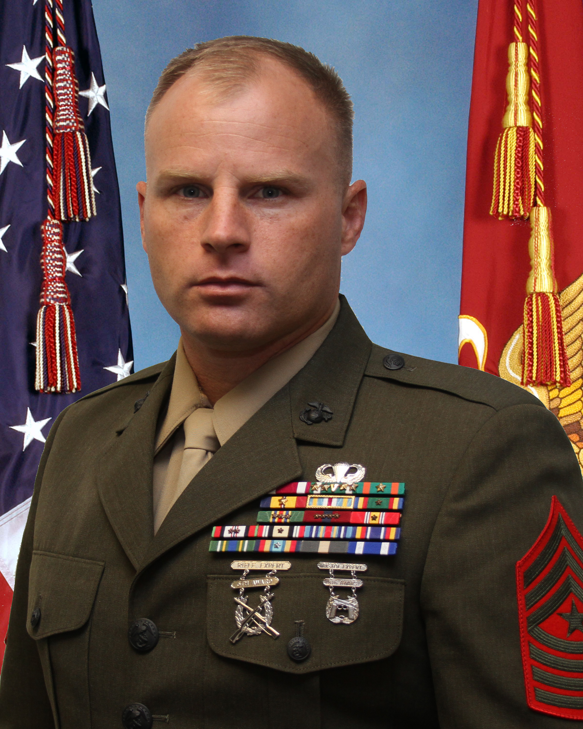
Colorado, western Nebraska, western South Dakota and Wyoming offer an abundance of recreational activities and interests; however there are no local Marine Corps installations and military bases are few and far between. Keeping this in mind, there are some important things to remember before your arrival at RS Denver:

UNIFORMS - Ensure that you have all prescribed uniforms to include medals and they meet uniform regulations for proper fit and serviceability. The reporting uniform is Service ‘A’. Once you arrive, there are remotely located uniform stores as well as mail-order uniform sales and Internet services available.

I.D. CARDS - All military identification cards should be current upon arrival. Buckley Air Force Base, Aurora, CO; FE Warren AFB; Cheyenne, WY; Ellsworth AFB, Rapid City, SD; Ft Carson AB, Colorado Springs, CO; and the US Air Force Academy have facilities available to make changes when required.

FAMILY SERVICE ORGANIZATIONS - MCCS One Source is available at 800-869-0278 and online at www.mccsonesource.com. The Fleet and Family Support Center, Buckley AFB (Aurora, CO) is available at 720-847-6681; Ellsworth AFB (Rapid City, SD) is available at 605-385-4663; USAFA (Colorado Springs, CO) is available at 719-333-3444; and Warren AFB (Cheyenne, WY) is available at 307-773-3739. There are also local Red Cross organizations in most areas. You must contact Tri-Care to change your Region upon your arrival.
CHILD CARE - Information concerning child care assistance can be found at www.naccrra.org (The Nation’s Network of Child Care Resource & Referral).
BANKING - If you are a member of Navy Federal Credit Union, you need to know that there is one location in the local Denver area. It is outside the Mississippi gate of Buckley AFB, on the corner of Tower and Mississippi. You may want to consider changing banks or opening another account while stationed at RS Denver for your convenience.
HOUSING - Local base housing is available for some RS Denver personnel. You may obtain housing information via the internet at:
  - www.buckleyafb.com
  - http://www.mybaseguide.com/air-force/academy/.
  - www.warren.af.mil
  - www.ellsworth.af.mil/

SNCOIC’S GUIDANCE

Welcome to your Recruiting Sub-Station, we are glad you are joining our team. As you will soon discover, recruiting duty will bring both the most rewarding as well as the most taxing times in your Marine Corps career. However, I know like all Marines who have come before you, you are up to the challenge!

There are many challenges facing recruiting today. None are new and none are fleeting, therefore the best remedy is to work hard and make mission. As a whole, Recruiting Station Denver has a history of crossing the finish line in a strong winning fashion month after month.

Accordingly, the Recruiters and I are here to help make your transition as smooth and effortless as possible. Furthermore, I trust that you will find this assignment to be both challenging and rewarding. Semper Fidelis and welcome!
ADMINISTRATIVE GUIDANCE

Prior to departure from Recruiters School:
I) Ensure that you have in your possession:
- Original Orders, beginning with orders to school, and all endorsements including a copy of your settled travel claim for Recruiting School prior to checking in.
- If your Orders have you checking in on the weekend, you must check in the Friday before during normal working hours (0800-1630).
- Your Service Record Book and Medical/Dental records.
- Ticket stubs for any official duty travel via common carrier (airplane, bus, etc.)
- Original receipts for official travel including temporary lodging receipts.
- You and your family’s ID cards (as applicable).
- Your Citi Bank Government Visa Card (if issued one).
- Your current civilian driver’s license.
II) Take the opportunity to elect several entitlements in conjunction with your PCS move.

RS CONTACT INFORMATION
MARINE CORPS RECRUITING STATION DENVER
225 East 16th Ave STE 500
Denver, Co 80203

Admin Phone: (303) 832-3021
Admin Fax: (303) 830-1194

ADMINISTRATIVE GUIDANCE
Continued

ADVANCE TRAVEL ENTITLEMENTS
- Advance Pay: “Normal parameters” are one month’s advance pay to be paid back in 12 months. This request may be submitted either 30 days in advance of departure from your old permanent duty station or within 180 days after arrival at your new duty station. Any requests for advance pay outside normal parameters must be justified.
- Advance Travel: Upon request, you should have received advance travel for yourself from your old Permanent Duty Station to Recruiters School. Recruiters School will cut the advance from San Diego to RS Denver. In the case of married Marines, you will rate travel time and transportation allowances back to the old PDS for yourself and then travel and transportation to your new duty station for yourself and your dependents.
- Advance Dislocation Allowance: Upon graduation from Recruiters School, you may request advance DLA. This entitlement is for the purpose of procuring housing at the new Permanent Duty Station. The rates are shown below:
Table U5G-1
Grade | Without-Dependent Rate | With-Dependent Rate
0-10 | $3,318.33 | $4,084.83
0-9 | $3,318.33 | $4,084.83
0-8 | $3,318.33 | $4,084.83
0-7 | $3,318.33 | $4,084.83
0-6 | $3,044.30 | $3,678.02
0-5 | $2,932.06 | $3,545.24
0-4 | $2,717.18 | $3,125.18
0-3 | $2,177.60 | $2,585.57
0-2 | $1,727.36 | $2,207.77
O-I | $1,454.55 | $1,973.62
0-3E | $2,351.42 | $2,778.73
0-2E | $1,998.96 | $2,507.16
0-1E | $1,718.91 | $2,316.41
W-5 | $2,760.62 | $3,016.54
W-4 | $2,451.60 | $2,765.48
W-3 | $2,060.52 | $2,533.70
W-2 | $1,829.98 | $2,330.91
W-1 | $1,531.80 | $2,015.87
E-9 | $2,013.46 | $2,654.41
E-8 | $1,848.07 | $2,446.80
E-7 | $1,578.89 | $2,271.76
E-6 | $1,429.19 | $2,099.14
E-5 | $1,318.15 | $1,887.89
E-4 | $1,146.73 | $1,887.89
E-3 | $1,125.01 | $1,887.89
E-2 | $913.77 | $1,887.89
E-1 | $814.81 | $1,887.89

ADMINISTRATIVE GUIDANCE

Continued

RATES OF TRAVEL ALLOWANCES
- Travel: .24 cents/mile (Standard)

- Per Diem: Paid for each travel day authorized on the orders that the individual actually utilizes.
Marine = $109.00/day
Spouse/Children over 12 = $81.75/day
Children under 12 = $54.50/day

IN TRANSIT
- Make sure you DO NOT ship all your uniforms in your TMO shipment as these items are frequently delayed or lost.
- You must contact your future SNCOIC and the RS Admin Chief, SSgt Myron Craig, prior to your arrival in the local area for guidance concerning temporary lodging allowances and housing availability.

***NOTE: Keep all lodging receipts for yourself and your dependents.

UPON ARRIVAL IN THE VICINITY OF RS DENVER
Call the RS Sergeant Major and your future SNCOIC to inform them of your arrival. You may check in to the RS prior to the date reflected on your orders if you wish.
Each Marine performing PCS travel is entitled to up to 10 days temporary lodging reimbursement either in the vicinity of their old permanent duty station, their new one, or a combination of both-not to exceed 10 days. This allowance will be reimbursed upon settlement of the Marine’s travel claim. Temporary Lodging Allowance is paid separate from your travel claim.

CHECKING-IN

Contact the Admin Section to inform them of the day you plan to check in. This will shorten your check-in time and make the process as pain-free as possible.
Check in goes Monday through Friday between 0800 and 1600 (excluding non-working holidays). All Marines checking in to the Command will check in wearing the Service ‘A’ uniform. Upon check in, you will receive a complete administrative, logistical and medical/dental briefing.

STATION ALLOWANCES
Please note that the following will not commence until you officially check in to RS Denver.
- SDA PAY = $450 per month
- BAS = $323.87 monthly
- BAH= Interim BAH will run until the time of your check in. This equals the amount of BAH at your old Permanent Duty Station.
MEDICAL/DENTAL INFORMATION

IF YOU REQUIRE MEDICAL ATTENTION IN TRANSIT
Immediately inform the RS Admin Chief and your future SNCOIC, then procure medical attention at the nearest available doctor. Keep all bills and submit them to the RS Admin Chief upon check in to facilitate claims processing.

IF YOUR DEPENDENTS REQUIRE MEDICAL ATTENTION IN TRANSIT
Call the TRICARE Healthcare Finder (HCF) line, (800) 444-5445, and follow the guidance listed below.
ALL TRICARE MEMBERS SHOULD:
- Call 911 or go to the nearest emergency room for emergency care.
- Carry your military ID card at all times and have your family carry theirs.
- Carry the number for the 24-hour TRICARE Health Care Finder Line (800) 444-5445. TRICARE Standard and Extra users can call the HCF line for assistance in locating TRICARE-approved providers. TRICARE Prime enrollees must contact an HCF operator to receive authorization for non-emergency care.
- Carry the number for the 24-hour TRICARE Health Care Information Line, (888) 563-2273. This service provides toll-free access (from within the United States) to over 500 recorded health topics or to a registered nurse.
- Keep all bills or other documentation if you are required to pay for health care services or prescriptions while you and your family are traveling. You will need to submit them in order to be reimbursed.

***NOTE If you receive emergency care while traveling and are admitted to a hospital, you or a family member must contact a HCF within 24 hours.
IMPORTANT PHONE NUMBERS
TMO/HOUSEHOLD GOODS

- Buckley AFB (720) 847-6685
- Ellsworth AFB (605) 385-2169
- Fort Carson (719) 526-3755
- Warren AFB (307) 773-1848
MEDICAL/DENTAL
- Buckley AFB (720) 847-9355
- Ellsworth AFB (605) 385-3215
- USAFA/Fort Carson (719) 457-2273
- Warren AFB (307) 773-3461
BASE OPERATOR
➢ Buckley AFB (720) 847-9011
➢ Ellsworth AFB (605) 385-1000
➢ Fort Carson (719) 526-5811
➢ USAFA (719) 333-1110
➢ Warren AFB (307) 773-1100

Recruiting Station Denver

RSS/PCS Locations & Phone Numbers

RSS CASPER: SNCOIC – SGT MOONEYHAN
601 SE Wyoming Blvd, Suite 1338
Casper, Wyoming 82609
(303) 234-3116
Fax: (307) 237-4219

PCS GILLETTE:
Camel Plaza 900 Camel Dr. Suite D
Gillette, Wyoming 82716
(307) 687-7842

PCS CODY:
314 Yellow Stone Ave Suite 210
Cody Wyoming 82414
(307) 587-5160
Fax: (307) 587-5213

TRF RIVERTON:
408 E. Main St. Suite #1
Riverton, Wyoming 82501
(307) 857-5770
Fax: (307) 857-5804

RSS CHEYENNE: SNCOIC – SSGT VELASQUEZ
1400 Dell Range Blvd Suite 33
Cheyenne, Wyoming 82009
(307) 772-2301
Fax: (307) 772-2020

PCS SCOTTSBLUFF:
2302 Frontage Rd
Scottsbuff, NE 69361
(308) 635-2914
Fax: (308) 653-3855

PCS STERLING:
214 Poplar St.
Sterling, CO 80751
(970) 522-9728
Fax: (907) 522-9743

RSS CO SPRINGS NORTH : SNCOIC – SSGT GRAY
5712 N. Academy Blvd
Colorado Springs, CO 80918
(719) 592-9595
Fax: (719) 535-2657

RSS CO SPRINGS SOUTH : SNCOIC – GYSGT CHATFIELD

697 Citadel Drive East
Colorado Springs, CO 80909
(719) 591-9328

RSS FORT COLLINS: SNCOIC –SGT MARTINEZ
132 Troutman Pkwy
Fort Collins CO 80525
(970) 223-0017
Fax: (970) 223-4919

PCS Greeley:
3230 W. 23rd Unit 310
Evens, CO 80620
(970) 330-5464
Fax: (970) 339-3241

RSS GRAND JUNCTION: SNCOIC – GYSGT STUCKENSCHNIEDER
2502 Highway Grand 50, Suite 600-C
Grand Junction, CO 81505
(970) 243-5071
Fax: (970) 243-2577

PCS MONTROSE:
636 E. Main St
Montrose, CO 81401
(970) 240-9539
Fax: (970) 240-9522

PCS GLENWOOD SPRINGS:
51027 US Highway Grand 24 Suite 175
Glenwood Springs, CO 81601
(970) 975-2577
Fax: (970) 945-5380

RSS METRO EAST: SNCOIC – SSGT MCLEOD
14177 E. Exposition Ave
Aurora, CO 80012
(303) 340-3700
Fax: (303) 343-6587

PCS Smokey Hill:
20269 Smokey Hill Rd Unit 1
Centennial, CO 80015
(720) 382-7903
Fax: (720) 382-7907

RSS METRO SOUTH: SNCOIC – GYSGT WALL
8966 W. Bowles Ave Suite U
Littleton, CO 80123
(303) 972-2259
Fax: (303) 972-1339

PCS LAKEWOOD:

145 S. Sheridan Blvd Unite 218
Lakewood, CO 80226

(303) 922-8170

RSS METRO NORTH: SNCOIC – GYSGT BENN
3053 Walnut St. Ste A/B
Boulder, CO 80301
(720) 974-1768
Fax: (303) 444-4638

PCS Longmont:
2255 N. Main St. Ste 115B
Longm0nt, CO 80501
(303) 682-5340
Fax: (303) 682-5341

PCS THORNTON:
550 E. Thornton Pkwy 170
Thornton, CO 80229
(303) 451-1738
Fax: (303) 252-9652

RSS METRO WEST: SNCOIC – GYSGT CALHOUN
7355 W. 88TH Ave Suite G
Westminster, CO 80021
(303) 456-5043
Fax: (303) 456-5046

PCS GOLDEN:
17700 S. Golden Rd. Suite 210
Golden, CO 80401
(303) 278-0368
Fax: (303) 278-8356

RSS PARKER: SNCOIC – SSGT OSBOURNE
11280 NWC South 20Mile Rd. Suite 109
Parker, CO 80134
(303) 996-6808
Fax: (303) 996-6841

PCS Castle Rock:
78 E. Allen St. Suite B
Castle Rock, CO 80108
(303) 814-7235
Fax: (303) 814-6093

RSS PUEBLO: SNCOIC – SGT PEREZ
4104 Outlook Blvd Suite 126B
Pueblo, CO 81008
(719) 545-4581
Fax: (719) 543-6077

TRF ALAMOSA:
817 Main St.

Alamosa, CO 81101
(719) 589-4866
Fax: (719) 589-0346

TRF LA JUNTA:
23 W. Fourth St,
La Junta, CO 81050
(719) 384-2869
Fax: (719) 384-7806

RSS RAPID CITY: SNCOIC – SGT JOHNSON
2200 N. Maple Ave Suite 120B
Rapid City, SD 57701
(605) 390-8063
Fax: (605) 348-5456

OSO DENVER: OIC – CAPT KATES
900 Aurora Parkway Suite 126
Denver, CO 80204
(303) 832-7121
Fax: (303) 832-7153

OSO FORT COLLINS: OIC – CAPT EMMISON
706 S. College Ave Suite 205A
Fort Collins, CO 80524
(970) 484-8118
Fax: (970) 482-4017

MEPS: NCOIC SSGT SOBO
721 19th Street
Denver, CO 80202
(303) 893-0479

Recruiter Administrative Information Sheet

1.
(Grade) (Last Name) (First Name) (M) (SSN) (MOS)

2. RSS / PCS assigned to:

3. Leave address:

Leave phone number:

4. Estimated date of check-in:

5. Marital Status: # of Dependents:

6. Government Charge Card Holder: Yes or No (Circle one)

7. Dependent Information:

Spouse Name: DOB:

Child Name: DOB:

Child Name: DOB:

Child Name: DOB:

Child Name: DOB:

8. Hobbies: ____________________________________________________________ ______________________________________________________________________________

9. Is there any situation/problem/information that may affect your tour of duty on recruiting (i.e. financial, marital, medical or otherwise) that should be discussed in private with the command? Yes or No

If Yes, explain:
_____

10. Any other specific information or assistance requested?

